**To customize your boot up logo to MDVR**

1. **To prepare your boot up logo at following image format:**

1.1 The image must be RGB mode.

1.2 The image must be JPG format.

1.3 The best image pixel should be 720x576.

1.4 The Image size must be less than 100 k.

1.5 The name of your logo image must be “loading.jpg”.

1.6 You will receive an image file <upgrading.jpg> from us.

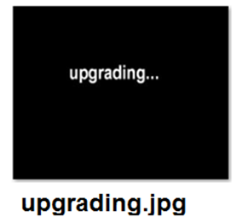

**2.** **To rename your logo file to be <****loading.jpg>**

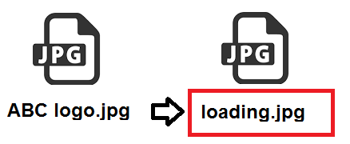

**3. Be advised that the different upgrade method for SD card MDVR and HDD MDVR**

**3.1 For SD card MDVR:**

3.1.1 To format your SD card to fat32, put both the <upgrading.jpg> and <loading.jpg”> under the Root directory of the SD card.

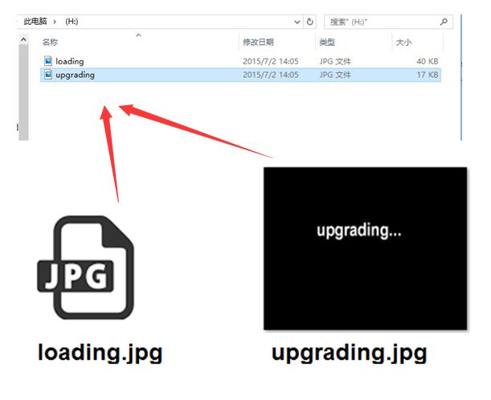

3.1.2 To insert the SD card into MDVR SD card slot, and then power up the MDVR.

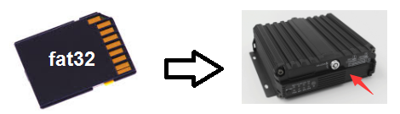

**3.2 For HDD MDVR**

3.2.1 To format your USB flash drive to fat32, put both the <upgrading.jpg> and <loading.jpg”> under the Root directory of the USB flash drive.



3.2.2 To insert the USB flash drive into the front USB port of the HDD MDVR, and then power up the MDVR.

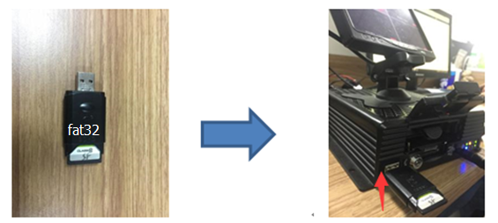

4. To log in the MDVR by follow steps:

SETUP MENU → TOOLS → CONFIGURE → UPGRADE LOGO

→ to click the “UPGRADE LOGO”

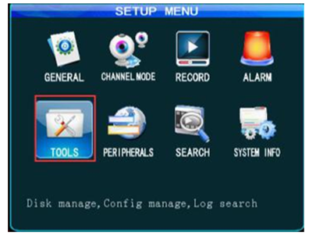



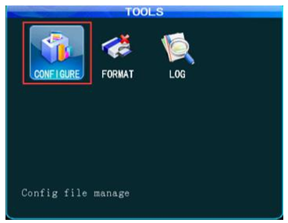



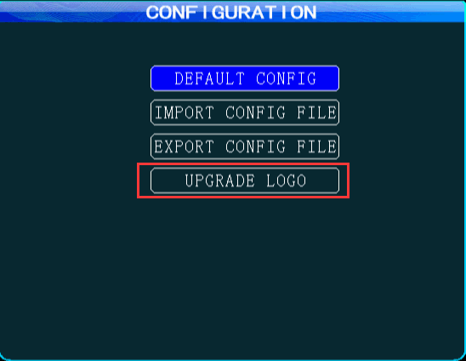

5. After clicking the “UPGRADE LOGO”, the pop-up window will show “Upgrade picture successful”.

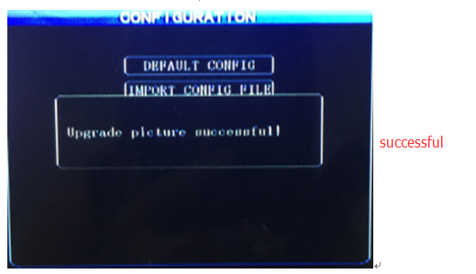

When you restart the MDVR again, your boot up logo will show up.

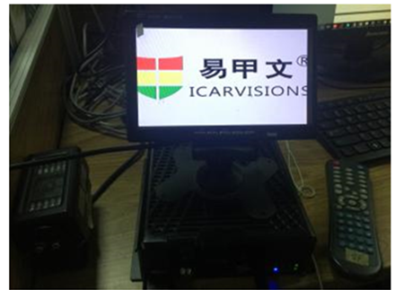

6. If you got failure message, like “No upgrade file!”, “no U-disk!”, “The upgrade file is too large!” ，please double check if your logo files compiled to above format requirements.

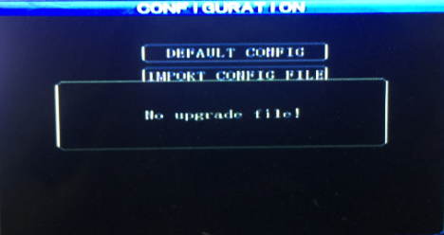

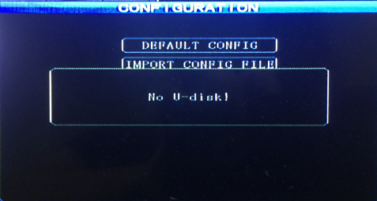

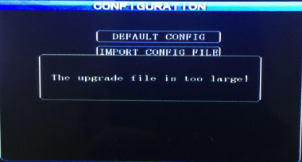

Please feel free to contact us if you have questions during the operation, or send your logo file to us, we can help to check the format and give advice.

sales@icarvisions.com